**Habit Tracker Screenshot guide**

Step 1 : Go in **app.py** and write **streamlit** **run app.py** in the terminal and the UI will open in the browser

Step 2 : You will see **Dropdown menu** on your left

Screenshot guide :-

* Click on **Create habit** to create a new habit and click on add habit

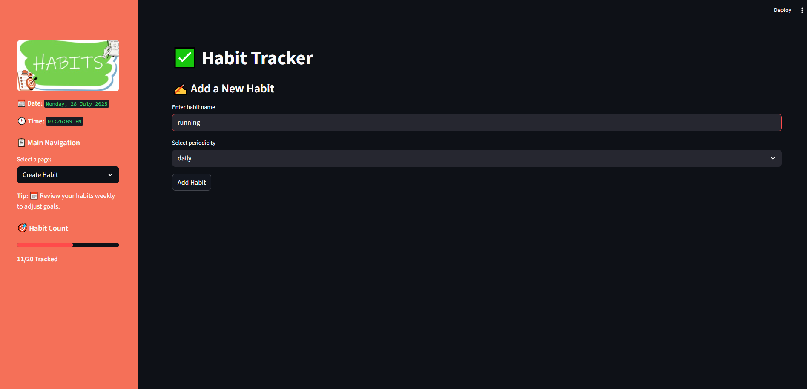

* Click on **View habit** to view your newly added habits and click on **mark completed** to mark as complete and click on **delete habit** to delete habit from database

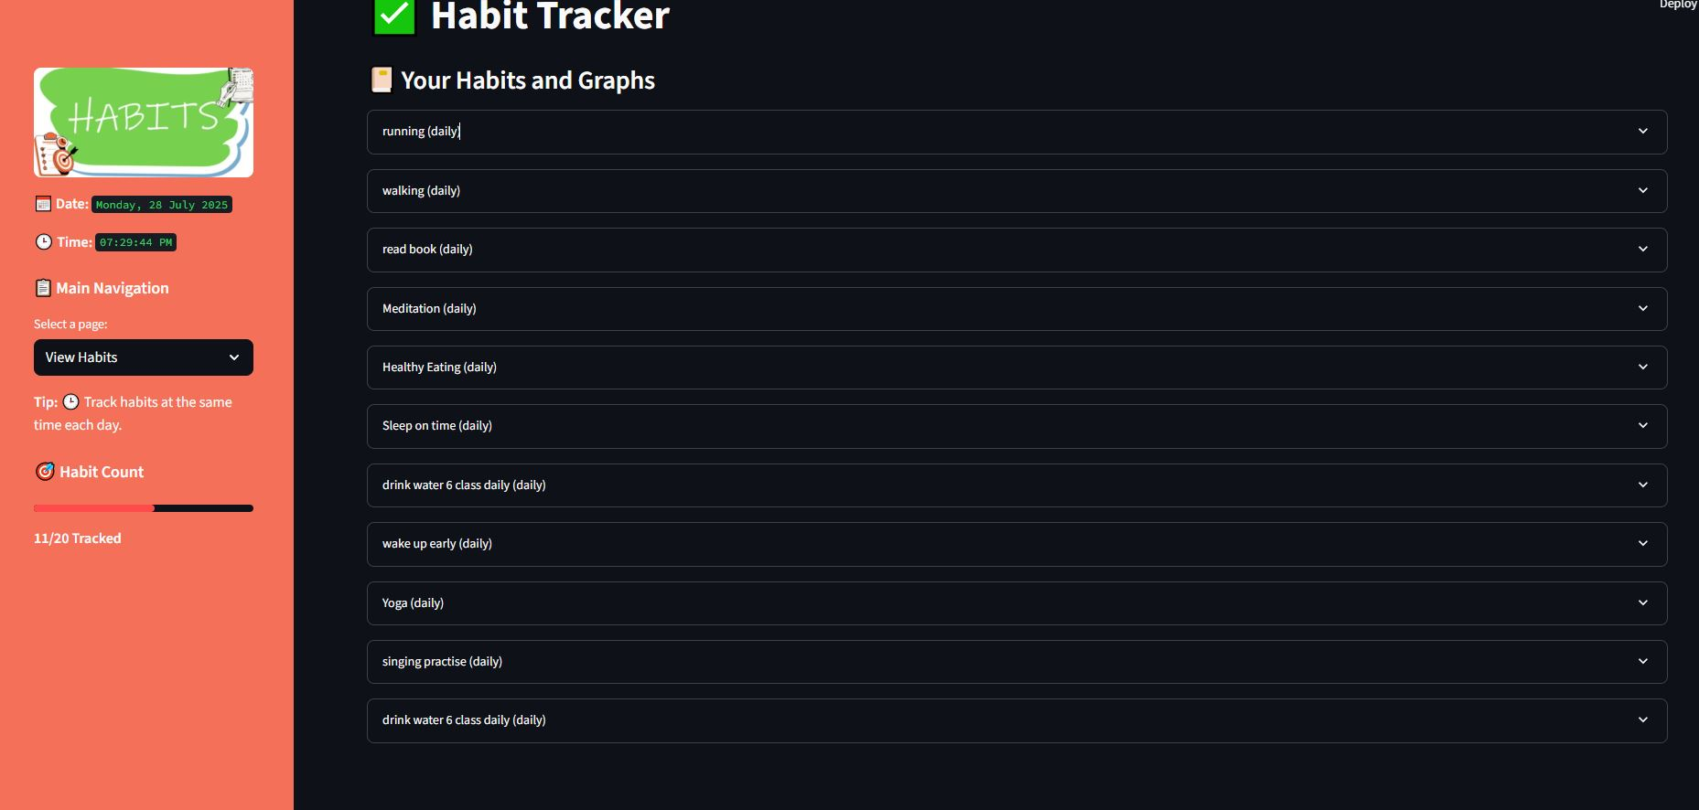

* **Mark Complete** and **Delete habit**

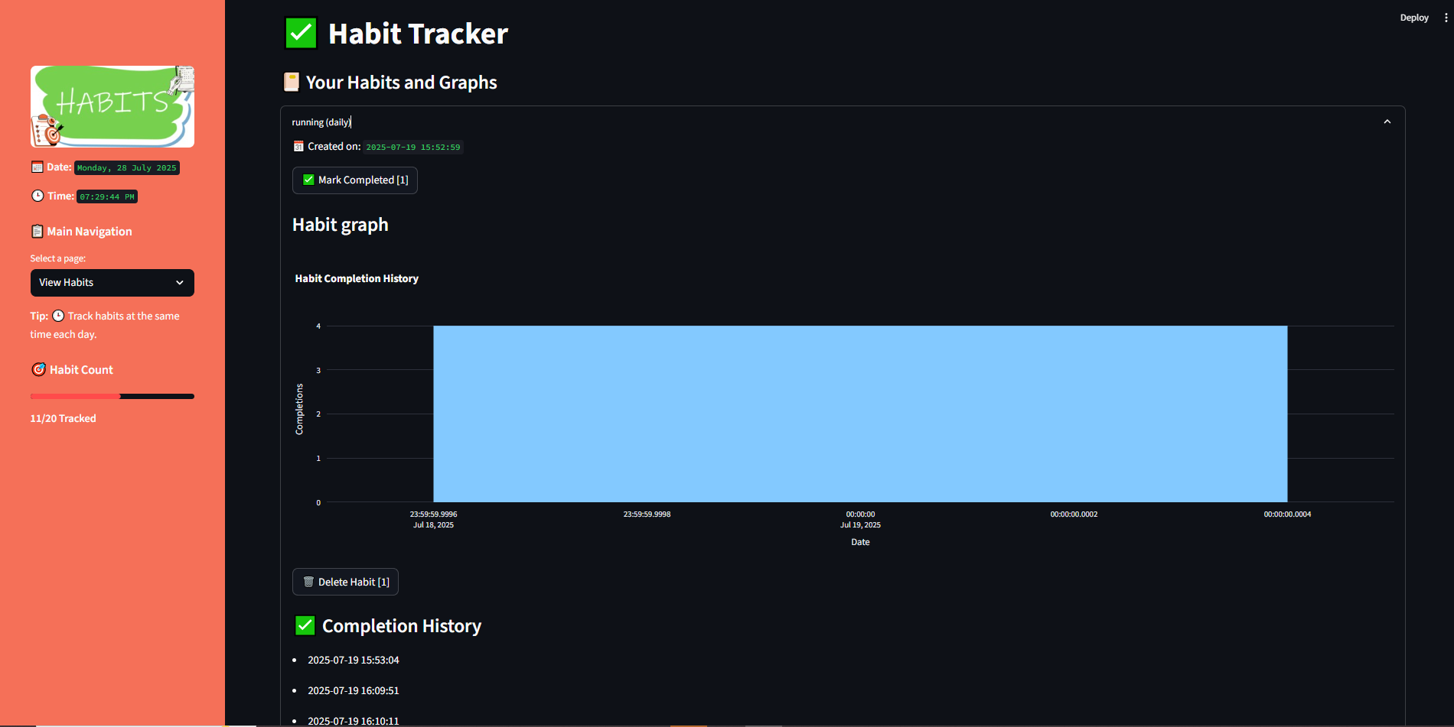

* Click on **Analytics** to view your streak

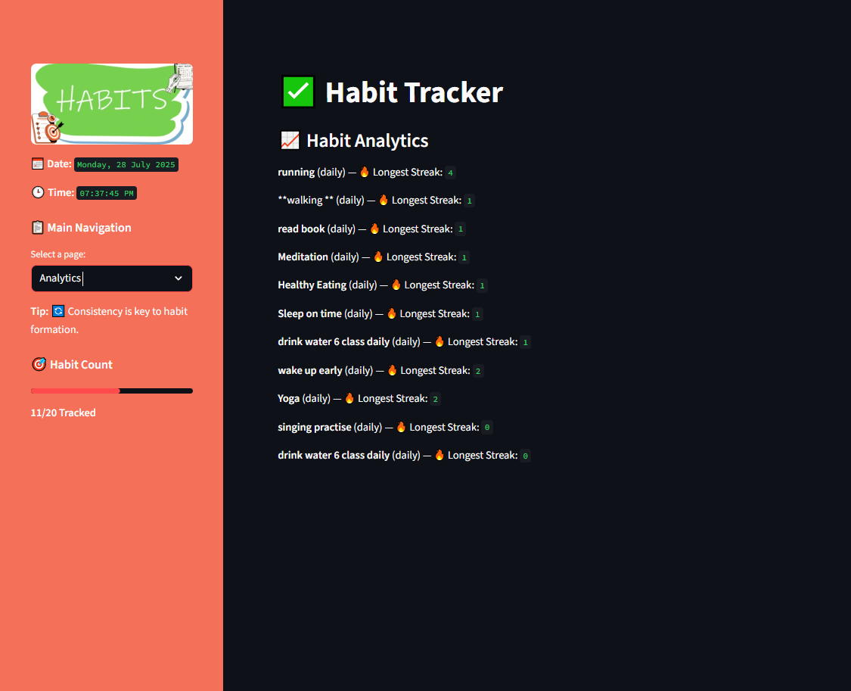

* Click on **Habit tracker info** to learn about the app and what technology used

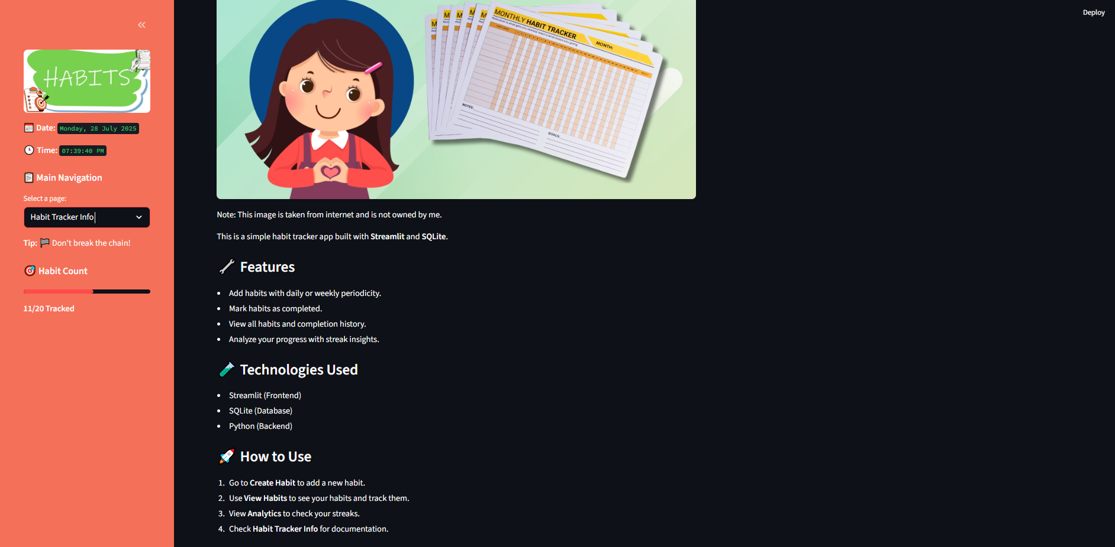

* Click on **Get habits** to see you on what **date/time** have you created your habits

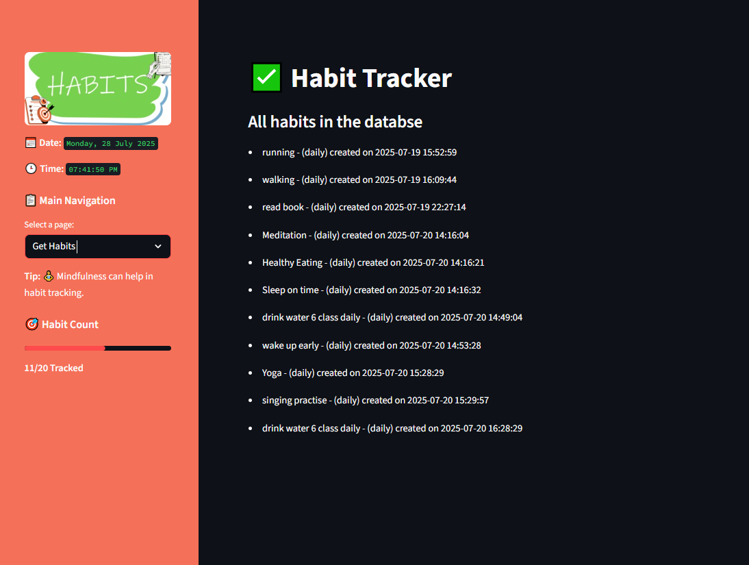

* Click on Dataframe to see data in table format

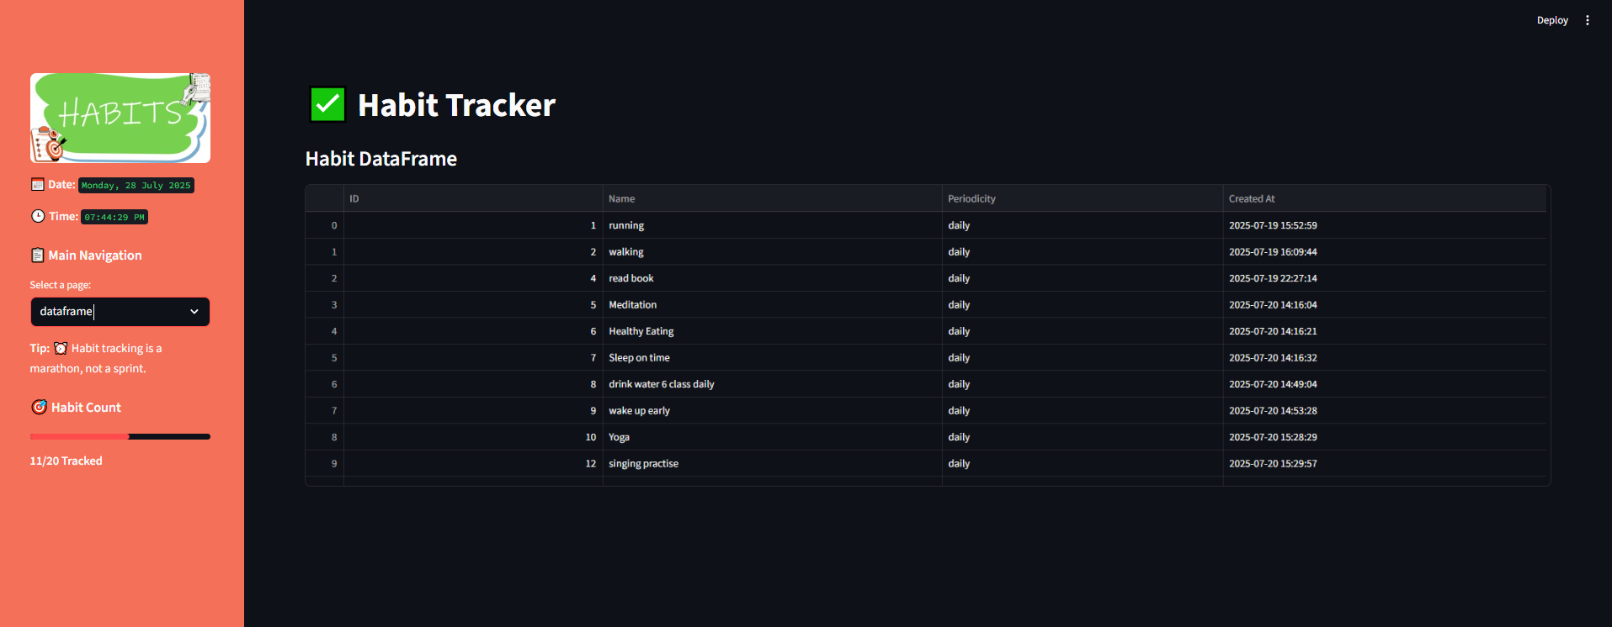

* On left you will see Basic info

